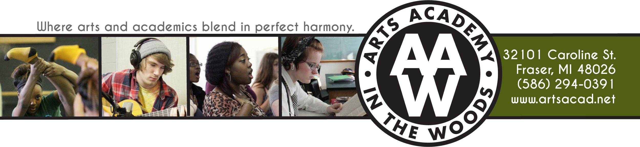

The National Honor Society of Arts Academy in the Woods
Important Information for Current Members

Maintain 3.0 or higher GPA

Semester Community Service Responsibility: 15 hours per semester (please see community service hours form for individual service)

Yearly Dues: $20 – Please turn into Ms. Chappelle by Friday, November 11th

Please follow the 4 Pillars of NHS by:
- Checking your email regularly
- Attend our monthly meetings consistently
- Make every effort to participate in NHS community service projects and events
- Turn-in your individual community service forms in a timely fashion (with all required information included)
- Set a positive example for new NHS members and AAW student body

